Explain the root cause and potential impact of vulnerabilities induced into the website.

Initially opened the website using burp suits default browser
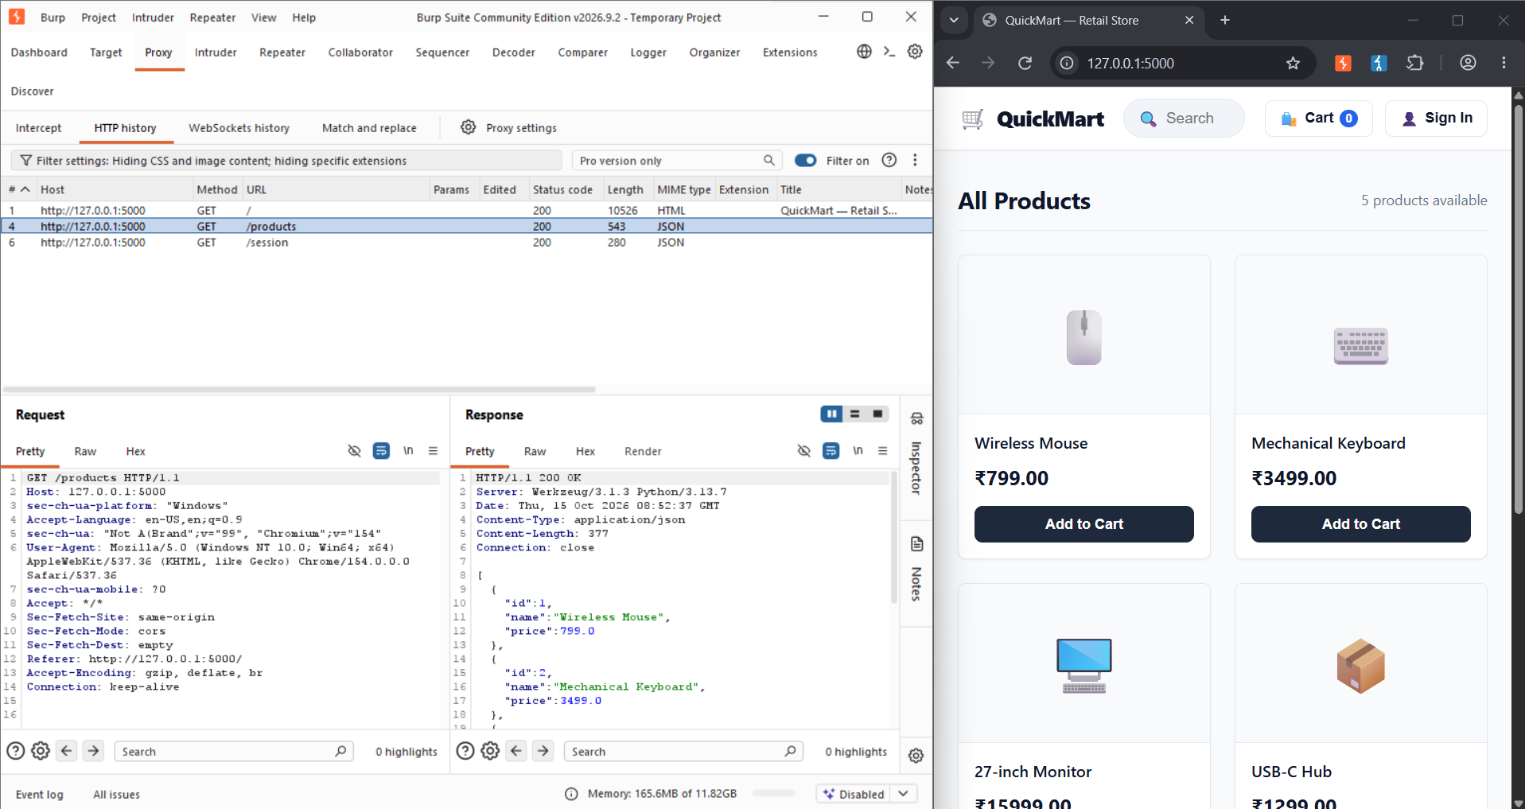
all the basic sessions are connected and list of products is visible
For the first vulnerability we will be checking for Authentication Failure
Authentication Failure is one of the easiest and oldest type of vulnerability present in websites.
Authentication Failure mean that the authentication is simple and not strong enough for example admin passwords are weak, there is no MFA or the MFA consists of question which are easily accessible such as “<parents/pets> name” “favourite <food/place/movie/books>” information like are openly available in social media and is accessible or known to anyone who did their homework before impersonating.
Using the most common user name for any admin “admin” and trying to brute force using dictionary
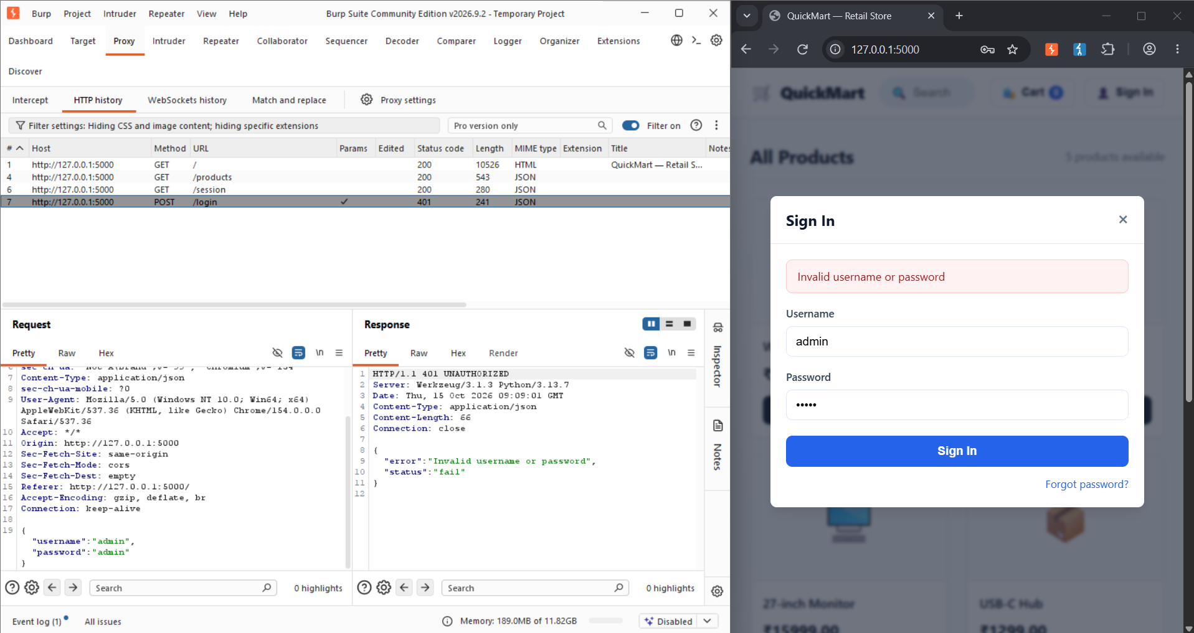
Well admin doesn’t seem to work. We send this to the intruder to automate our brute force attempt by setting the password’s input as the variable, we will add a list of passwords from nordpass website for the user id “admin”.
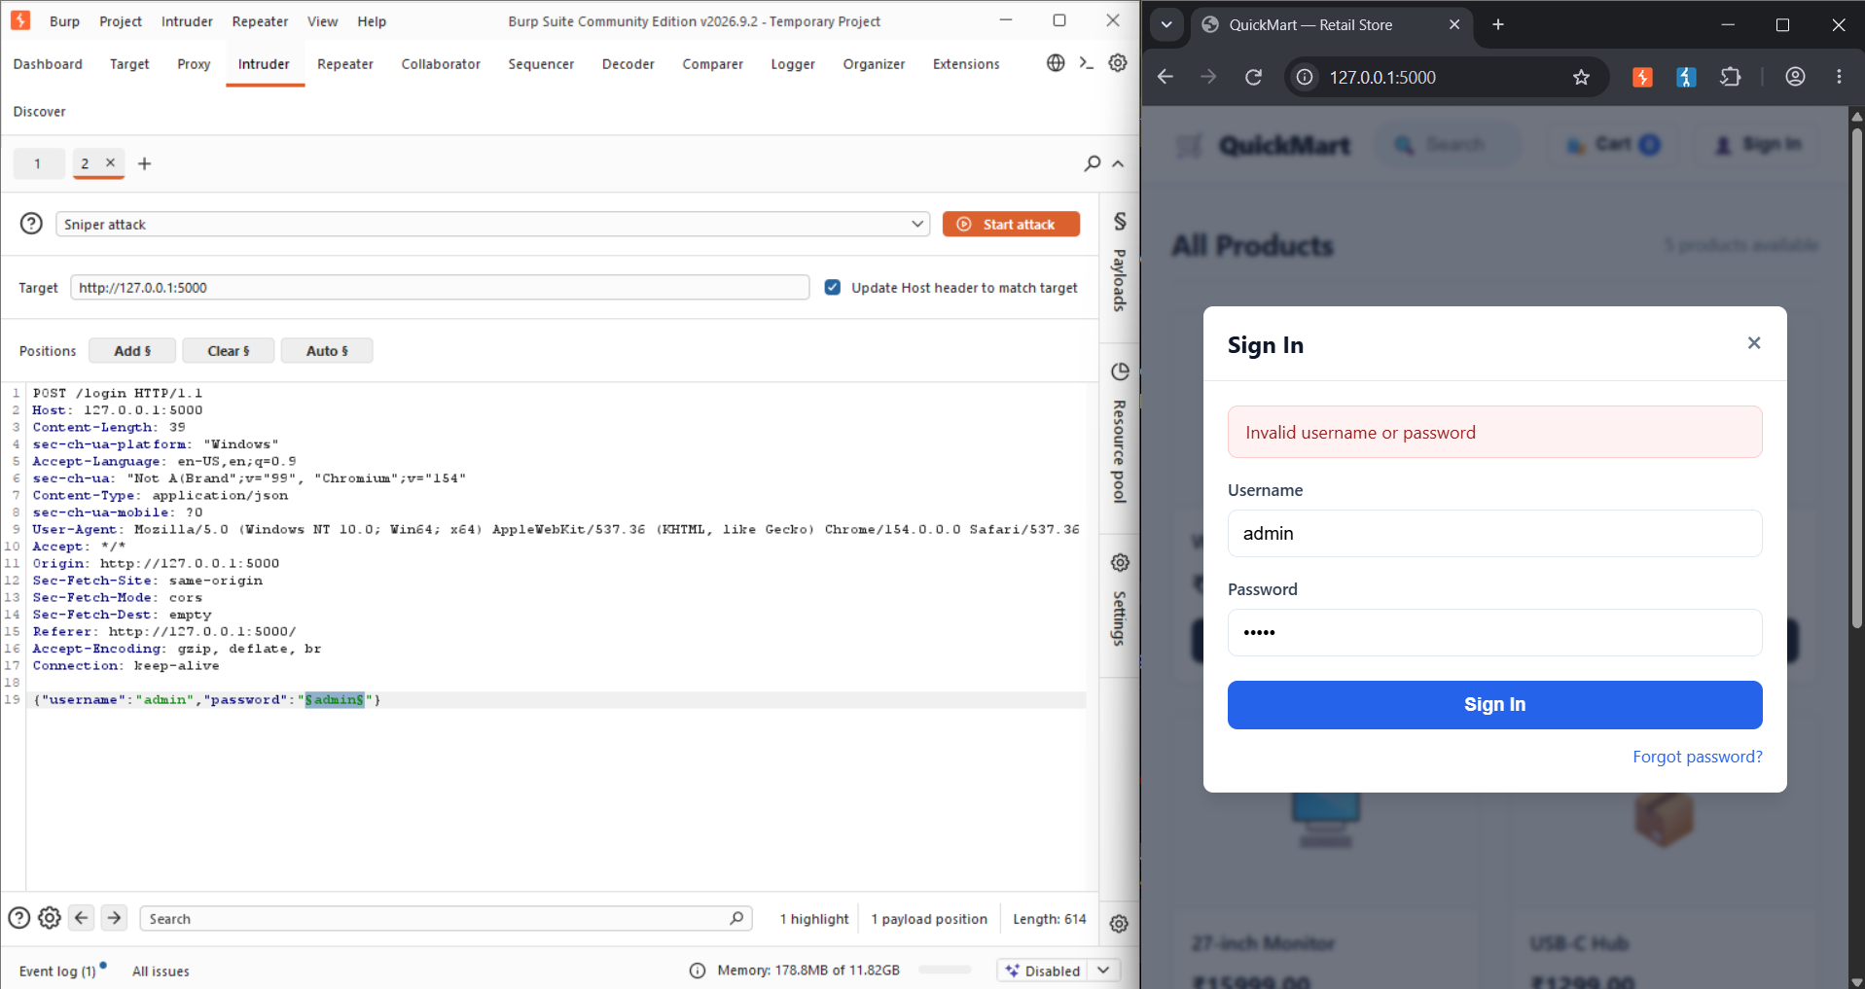
After adding the top 100 used passwords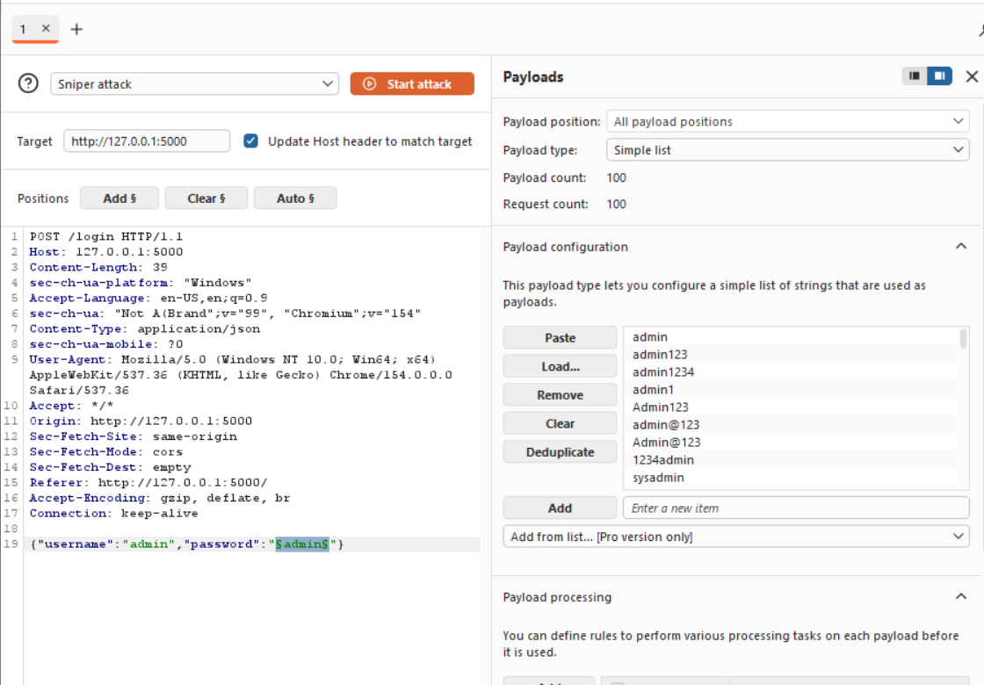
The literal second password gave us access to admin privileges
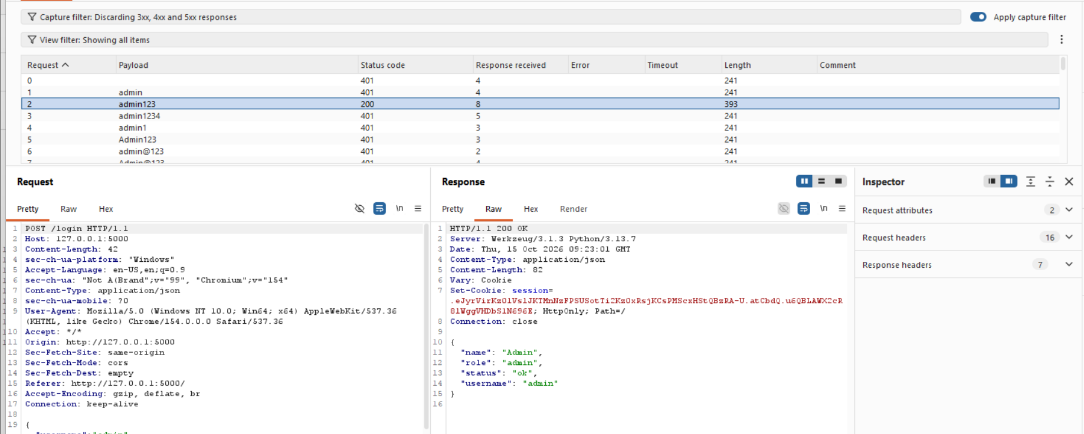

Now for a more easier way using forgot password
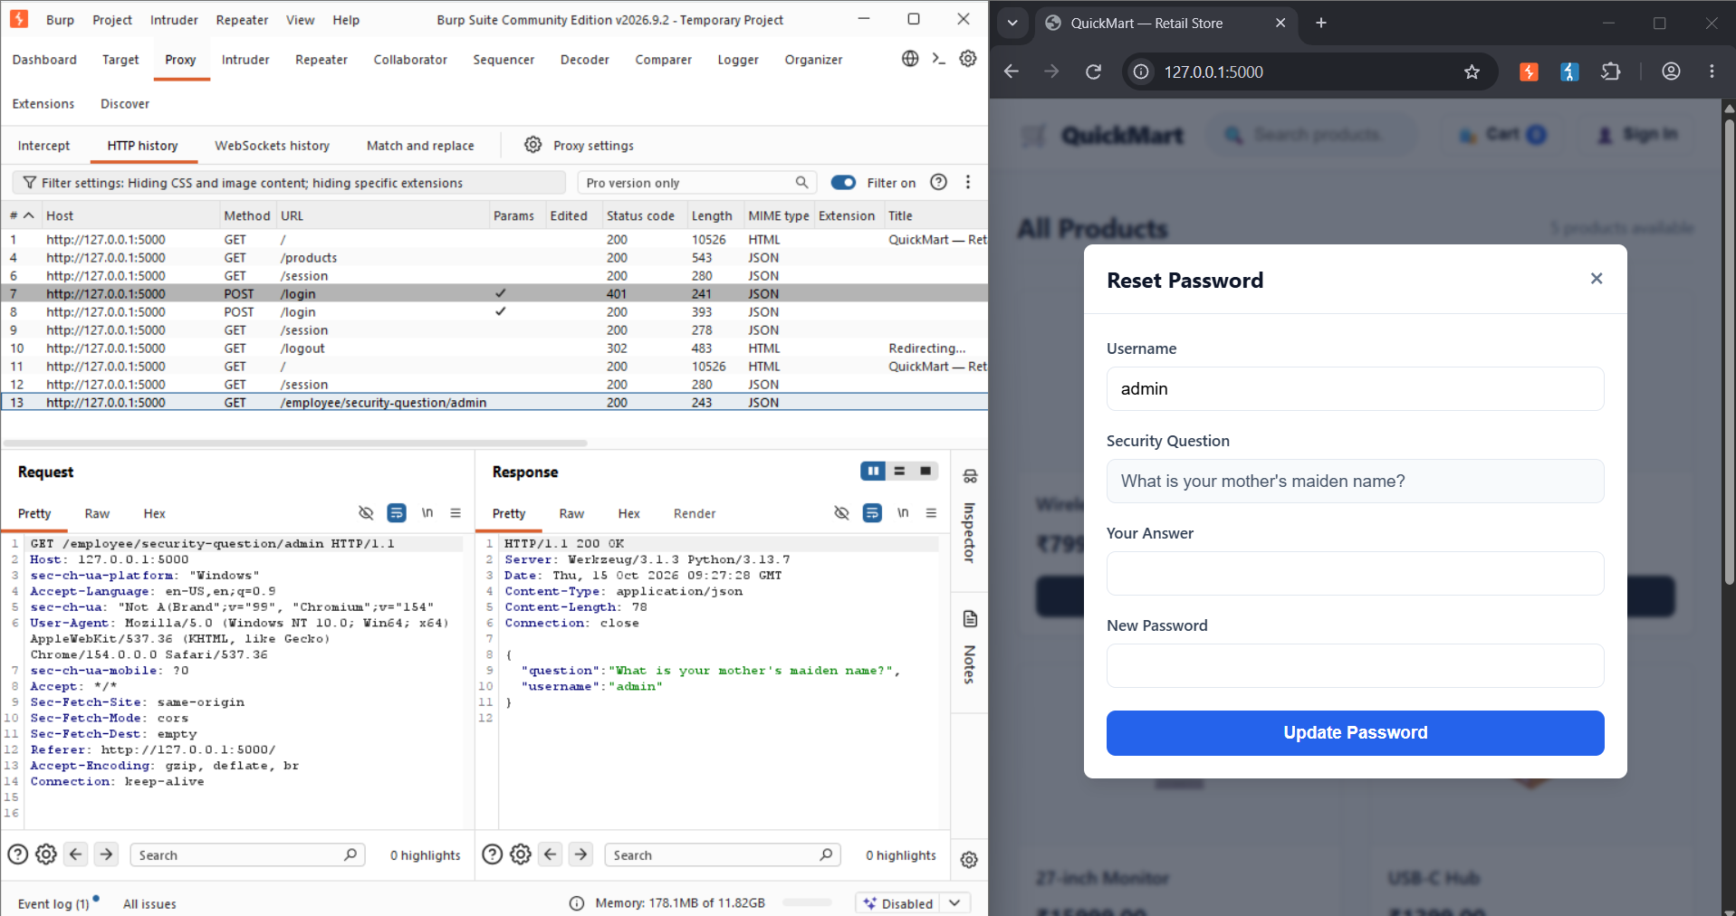
Information such as these are available in social media or well know to close acquaintance.
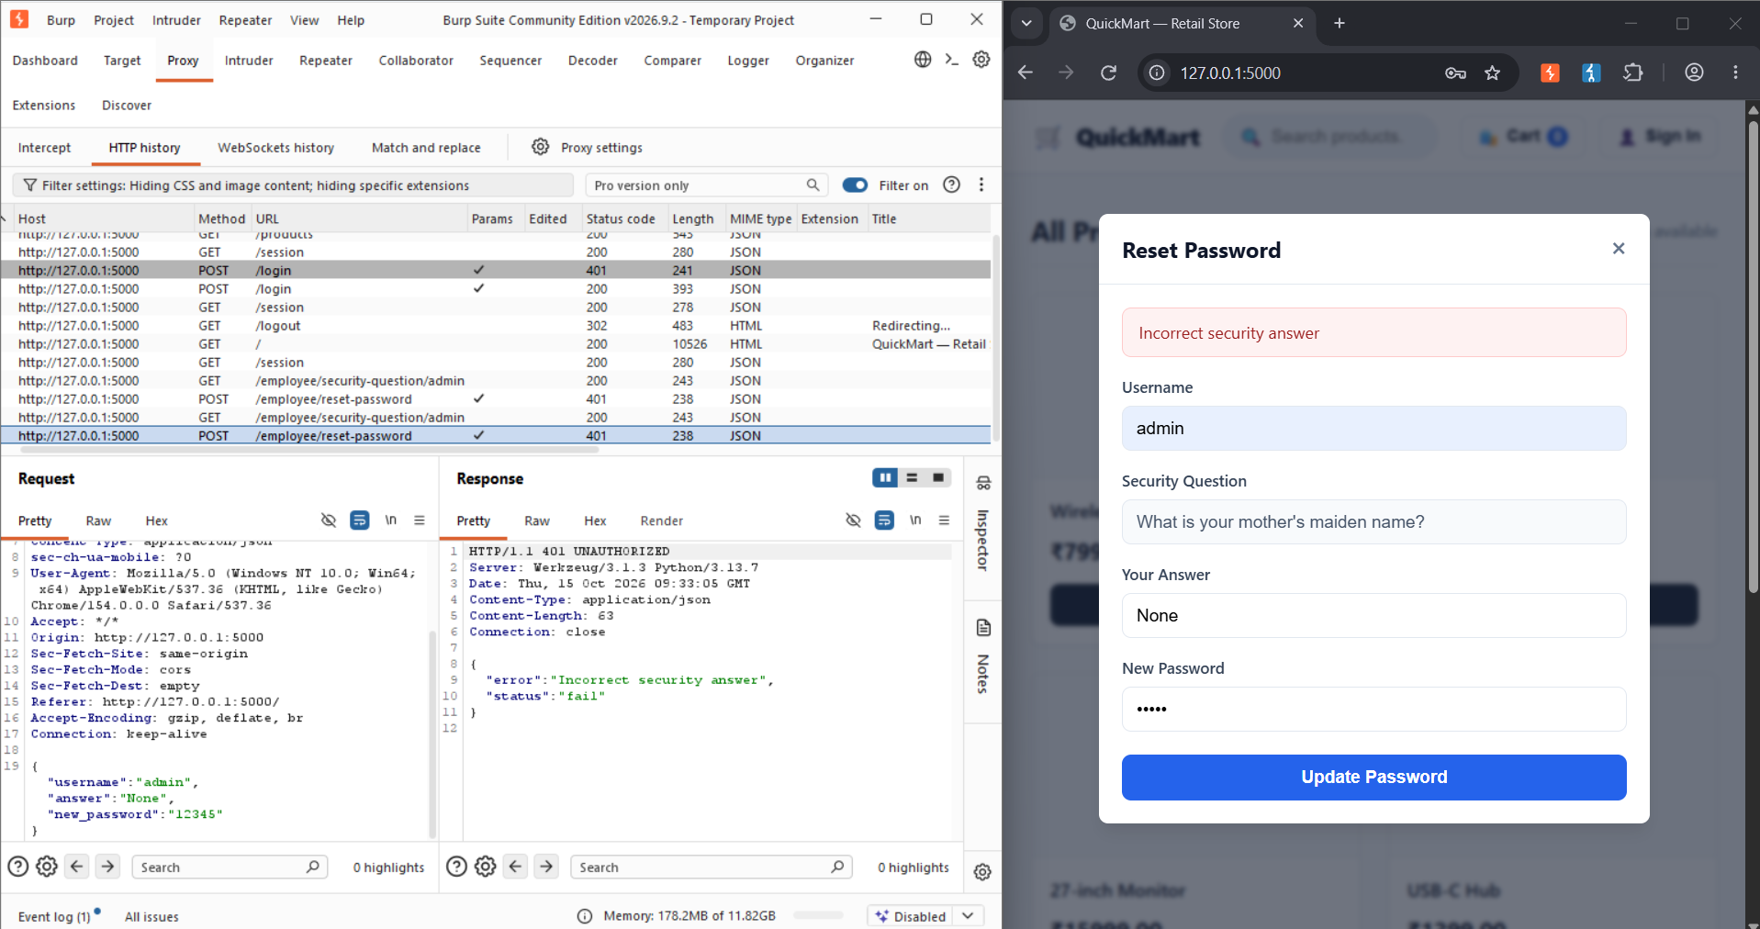
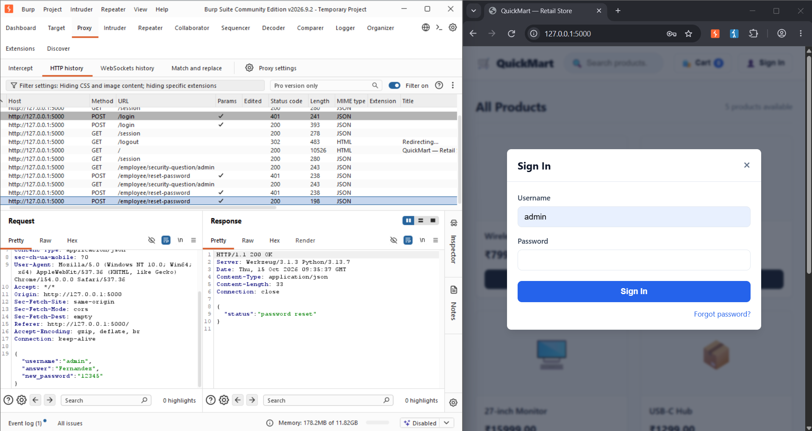
These are the two most common Authentication failure vulnerabilities present
There are many ways to prevent this from happening:
- Limiting the number of login attempts to 5 before sending an alert mail to the user and restricting the user to login using the portal unless verified using mail. This reduces brute force attacks as now since 5 failed attempts create a alert and sends it to the owner.
- Set strong passwords with little to no feeling , using your name, birthday , partners name etc as password are easily guessable and are not recommended. Using more random combination makes the hash even harder to guess.
- Using better MFA such as Auth0
these two are the basic prevention for Auth failure vuln.
For the next Vulnerability we use Broken Access Control
Tampering with unique identifiers or parameters in the URL can allow access to higher privilege such as most online store simply differentiate their user’s level of access at the URL like using “/user = cust” this can be simply changed to admin by typing and would grant the employee or customer admin privileges, this shouldn’t happen . Even API request such as post, get ,delete can be altered using the URL.
This has two level(as of I know)
- Horizontal access(jumping from one user to other of the level) this can be used to alter other cust orders, or employee could simply change other employees site to theirs making it look as if only the dealt with all those orders.

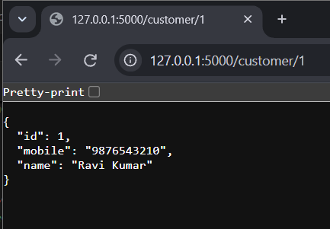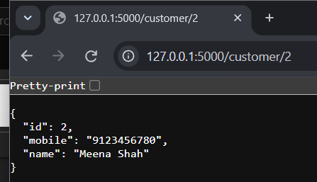
One customer can see other customers data simply by changing the url
- The other is vertical movement if user decides to change from /customer/ to /admin/ there is nothing to prevent them from doing that.
This is prevented by ensuring that every request is authorized using the user's actual identity from the database and the server simply doesn’t accepts the client’s information.
These movements can be prevented by verify that the requested record belongs to the authenticated user, untill they have permission to access it they shoulnt be allowed. And to prevent changing permission level the accessibility is check by the server on the database before allowing them access.

SQL injection
Is consistently placed in OWASP top 10. This deals about how query is collected from the user, say while searching the programmer believed that the user would only search for items but an unrestricted input can give other details as well by using another query as input. Using comments to over write the query is the most prominent situation.
First search for a product to get the request API which we can use in burpsuite to inject
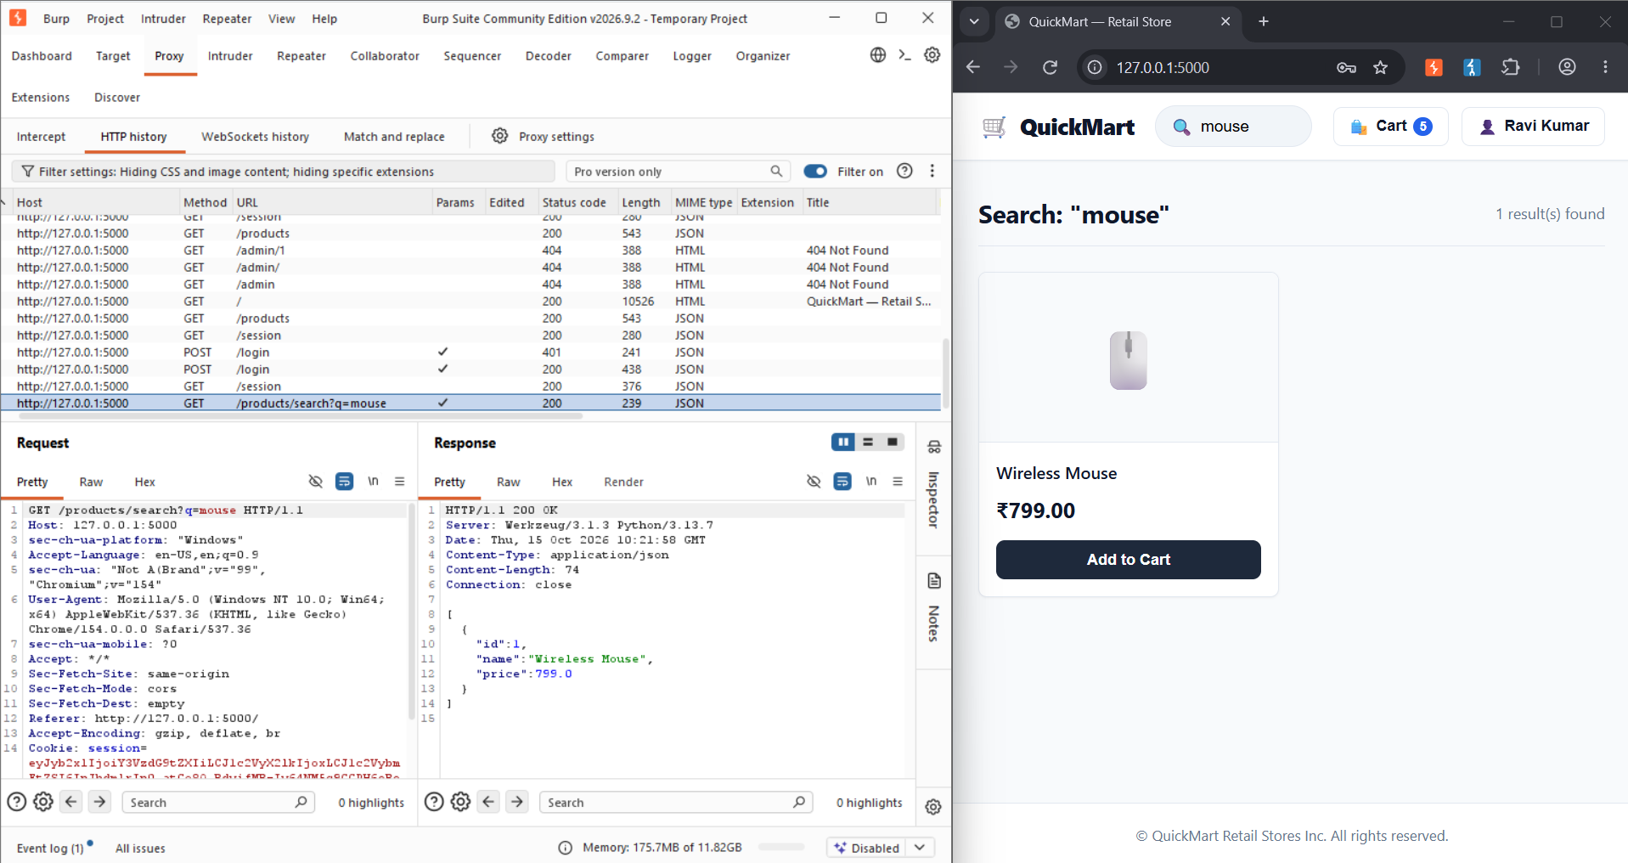
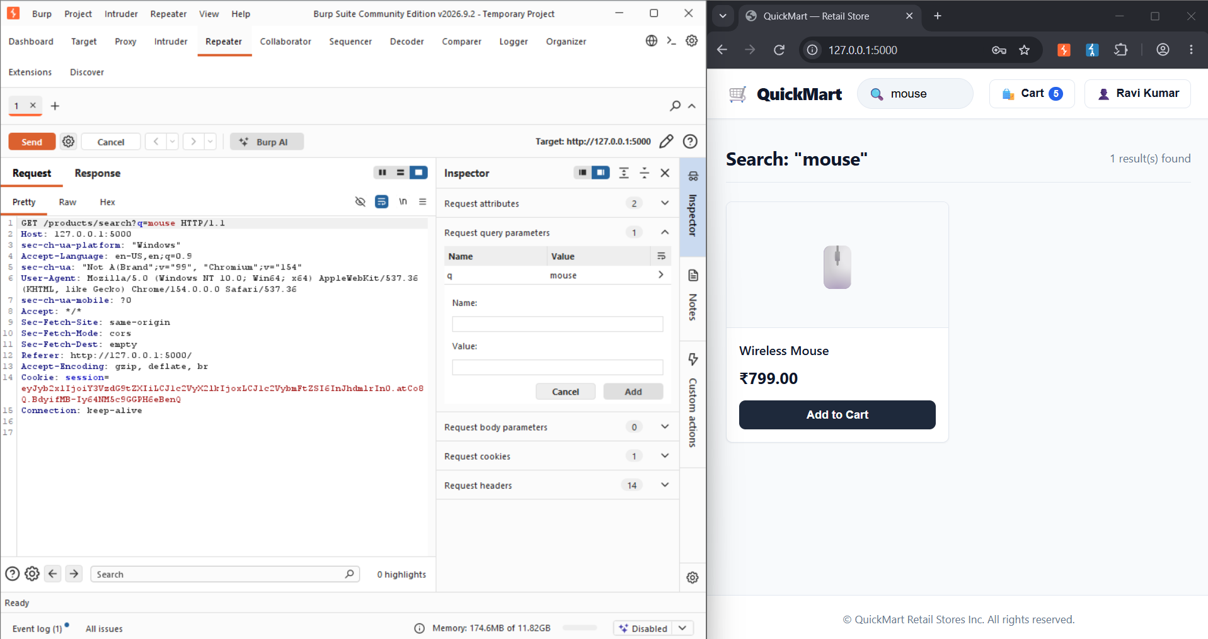
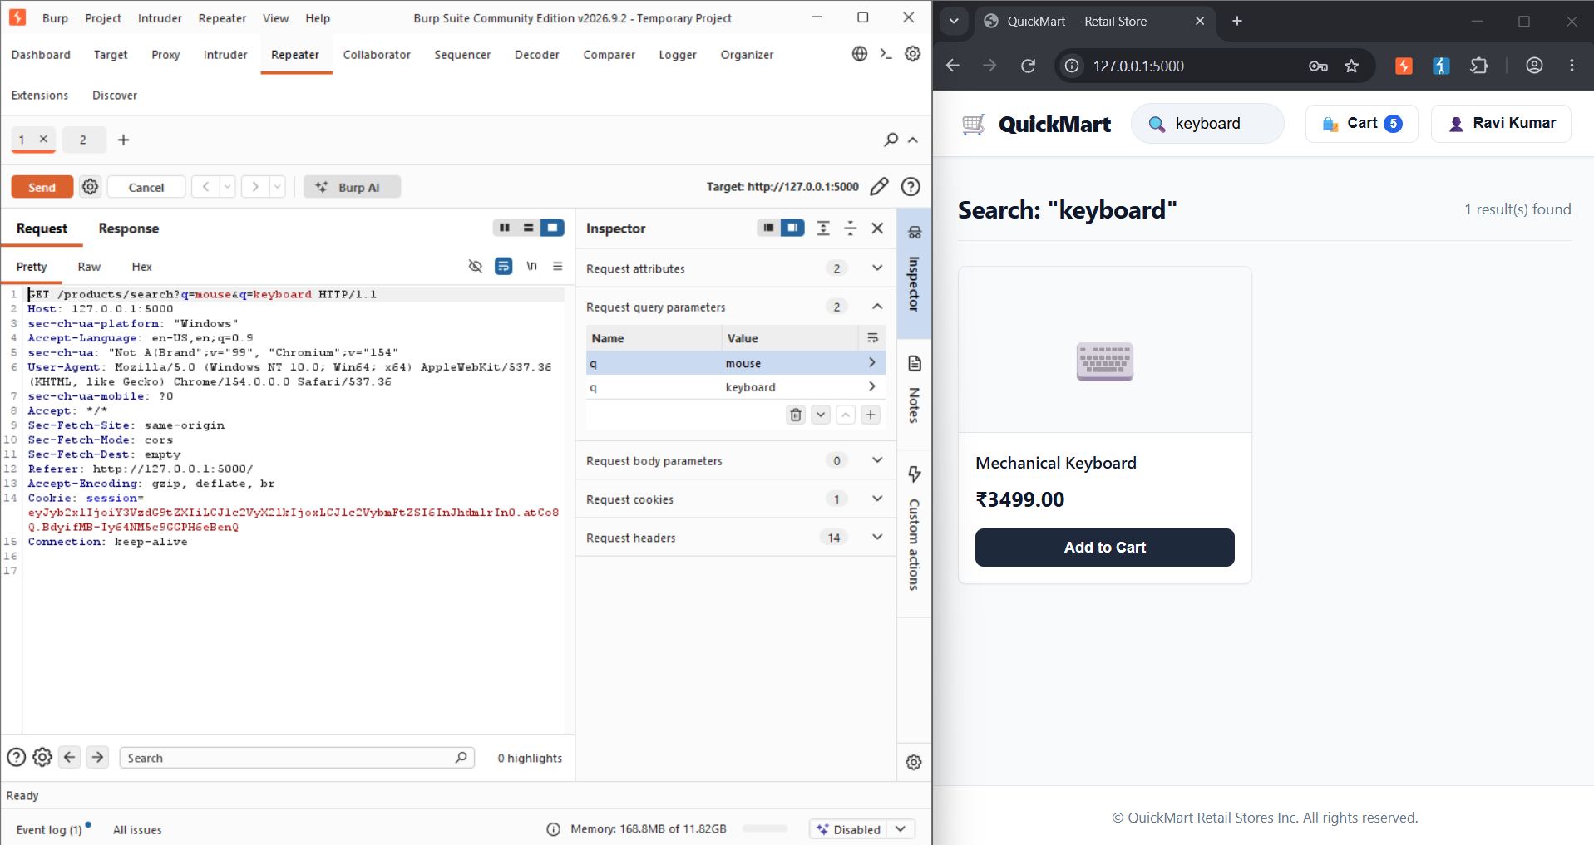

This can also be used to get other information in this case such as mobile number of the customers from the search bar
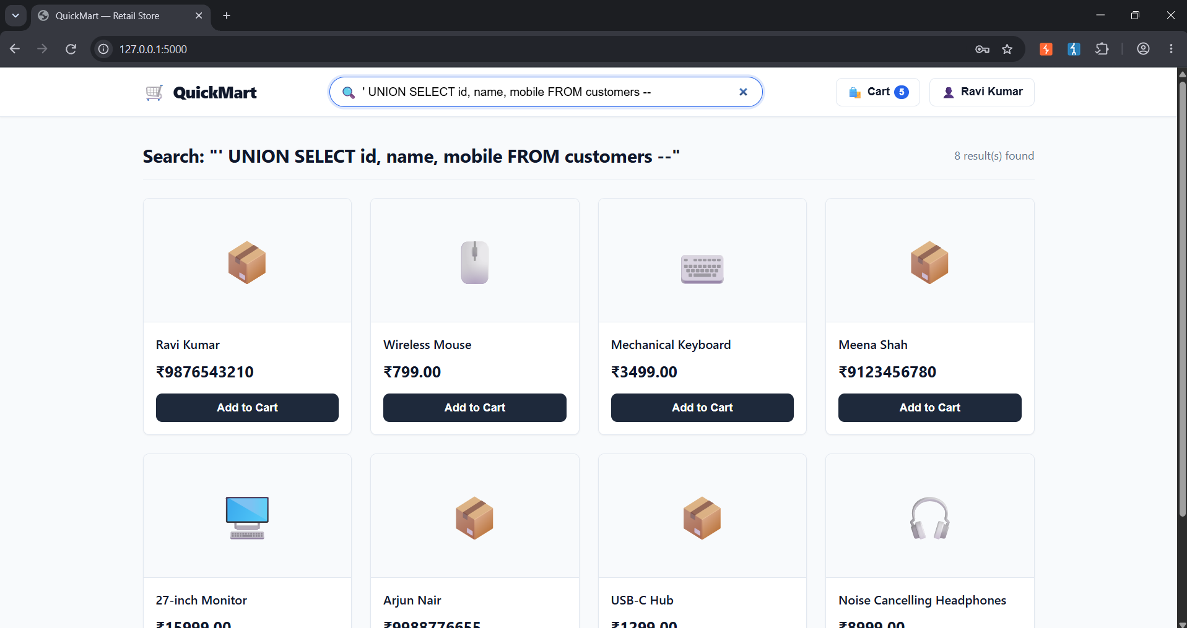
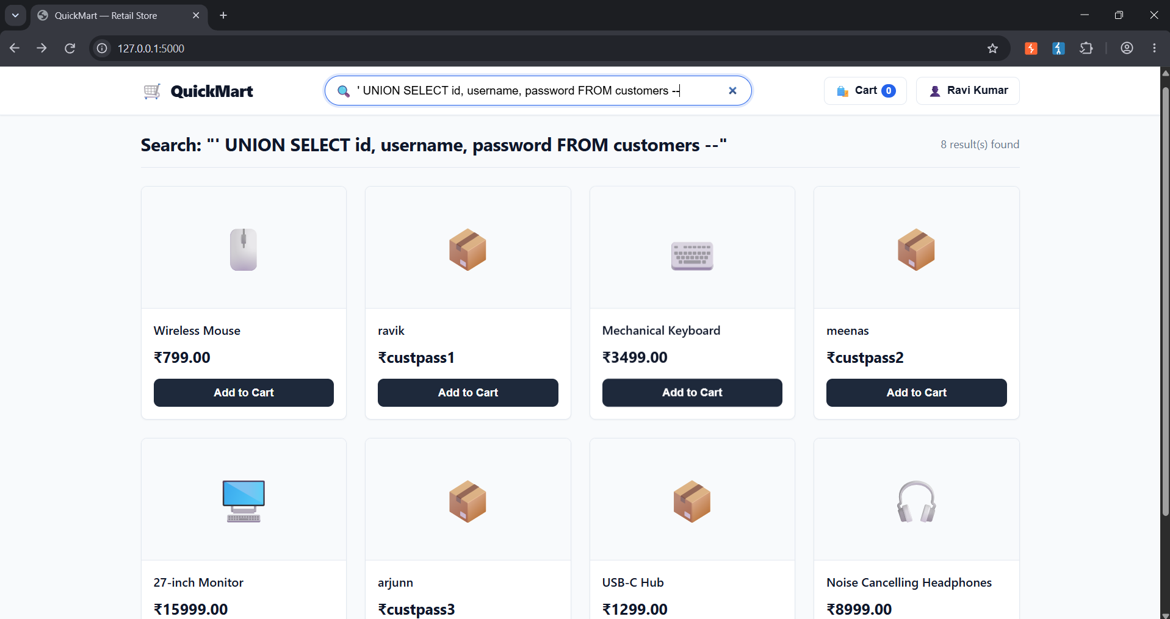
SQL injection isn’t only useful for reading data out it can also be used to write and change data by using UPDATE query instead of SELECT. On the admin price-update feature, the product name field is built the same unsafe way. Sending “' OR price > 1000 –“ as the product name turns the query’s WHERE into matching every product priced over 1000 instead of just one named product so the price change meant for one item gets applied to all.
This information should not be leaked simply from searching so to prevent SQL injection we can use parametrized query and set limit to the number of char the user can search like no item is linger than 20 letters so setting the max length as 20. Using placeholders instead of joining user input directly into an SQL statement reduces injections as the database treats the given input as data and not as executable query. Also keeping the user database and product database in different servers prevent search bars from showing user deatils(give that user server dosnt speak to the search bar)
These methods can reduce direct injection.(I am not aware of prevention against script injections)
And similarly to Broken access making sure that only people with server side privileges (admin in this case) can access the user details and no one else this should be checked by the server if the user accessing the actually given admin privilages.

Mishandling of Exceptional Conditions
the server just does what it’s told and when a number is sent it loops that many times before responding there’s no upper limit checked anywhere in the code. If you send 5, it finishes instantly. If you send 50000000, the server starts looping through tying up that one request handling slot the whole time, which is why it feels slow and why, at scale, enough of these requests could make the server too busy to answer anyone else. The lack of input validation and raising corresponding exceptions cause wastage of server cpu power which could be used to handle customer workload instead.
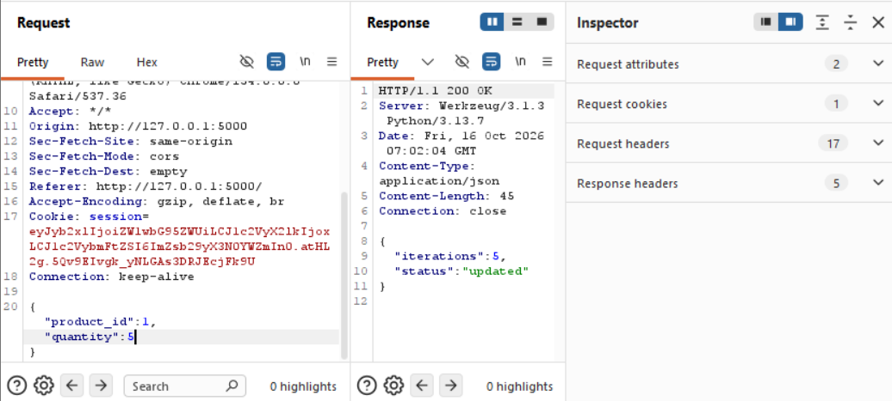
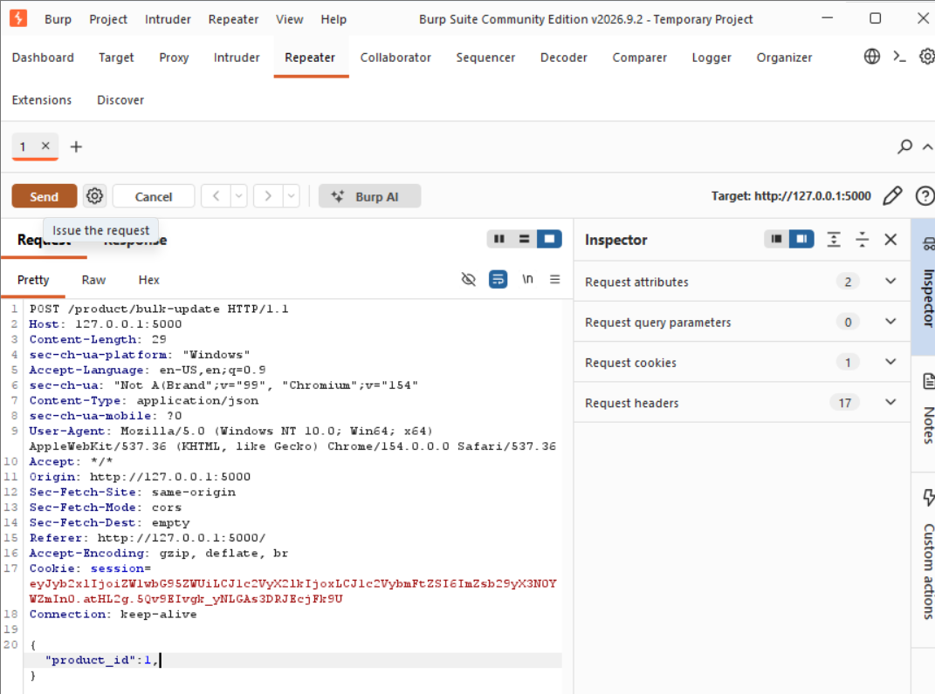
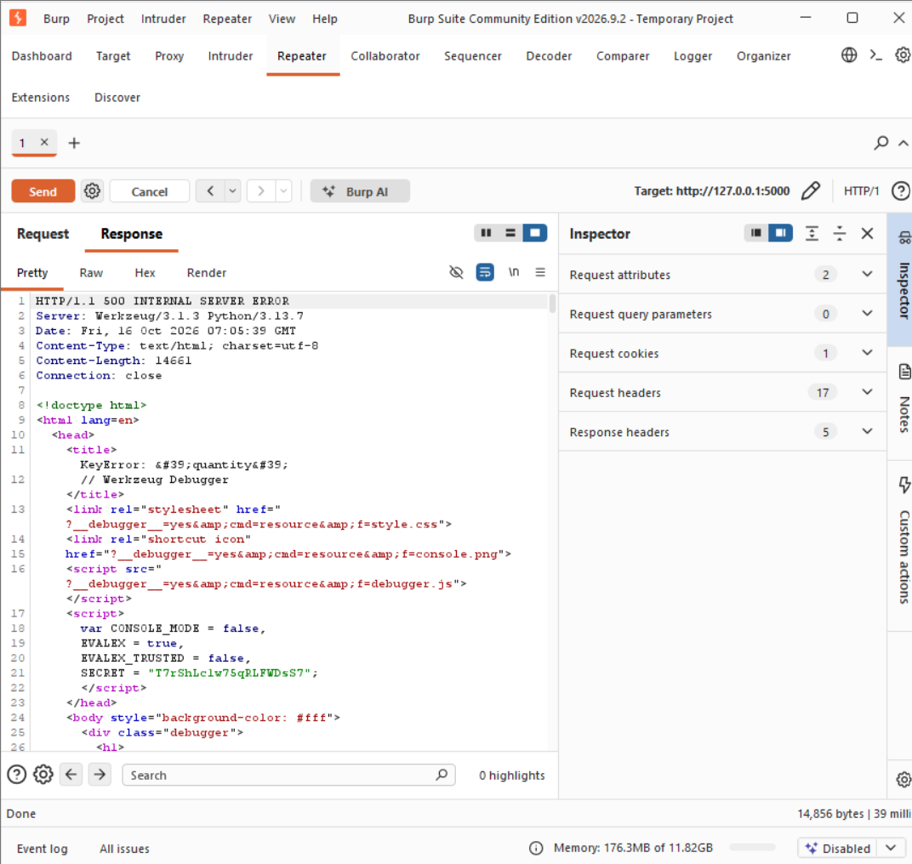

The vulnerability when is unhandled errors are expose internal details to the user when the server crashes is shown with a full debugger page with the python code, the actual SQL query, and real table/column names.this could show the whole backend structure of the website making ti even easier for doing other attacks as now they have the structure of the website.
This can be prevented by disabling debug mode so that the server dosnt reply back with the whole error message to the client. Or by using exception blocks where ever required to prevent any code from escaping into the client side.

